Fake Discord Application Database Design Document
INFORMATION MANAGEMENT FINAL PROJECT

Last Updated: March 06, 2025

Prepared by:
ESPIN, KYLE CEDRIC
CADIZ, ANTONETTE MHYLS

1. Introduction
Project Name: FakeDiscordApp
Purpose: The database is designed to support a Discord-like application, enabling users to communicate via direct messages and channels, join servers, and manage friendships.
Scope: The database will store user information, friendships, direct messages, servers, channels, channel messages, server members, and server invites.
Audience: Developers, Database Administrators (DBAs), and stakeholders.
Version: 1.0
Last Updated: 3/6/2025

2. Database Overview
Database Type: Relational Database
Database Management System (DBMS): MySQL
Database Name: fake_discord
Description: The database is designed to manage user interactions, server memberships, and messaging functionalities for a Discord-like application.

3. Entity-Relationship Diagram (ERD)

Below is a high-level description of the ERD:
- Users can send Direct Messages to other users.
- Users can have Friends (many-to-many relationship).
- Servers are owned by a user and contain multiple Channels.
- Channels contain Channel Messages sent by users.
- Server Members represent users who are part of a server.
- Server Invites allow users to invite others to join a server.
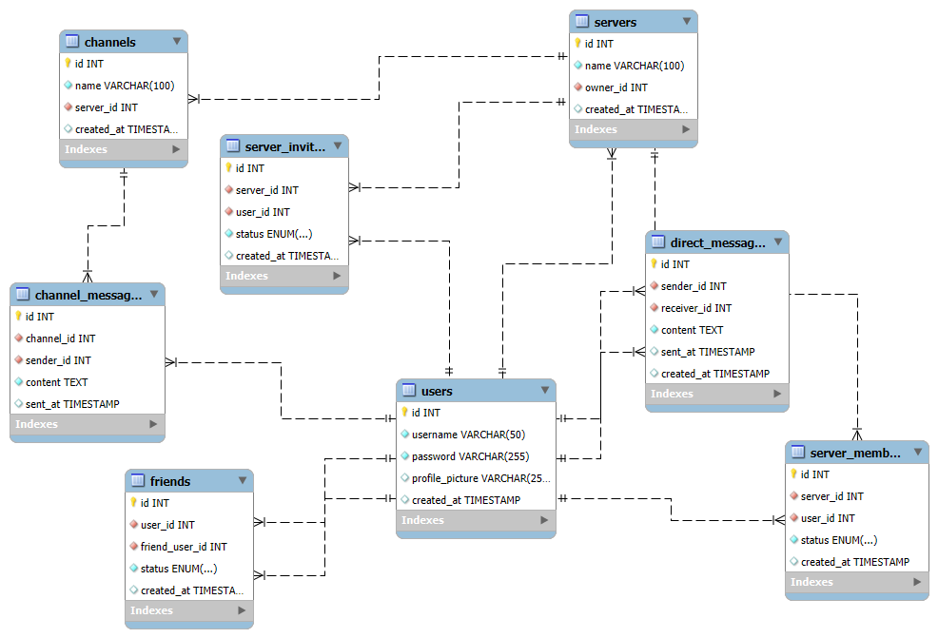

4. Tables and Schema

Table Name: users
Description: Stores user information.
Column Name | Data Type | Constraints | Description
id | INT | PRIMARY KEY, AUTO_INCREMENT | Unique identifier for the user
username | VARCHAR(50) | NOT NULL, UNIQUE | User's username
password | VARCHAR(255) | NOT NULL | Hashed password
profile_picture | VARCHAR(255) |  | Path to the user's profile picture
created_at | TIMESTAMP | DEFAULT CURRENT_TIMESTAMP | Timestamp of user creation

Table Name: friends
Description: Stores friend relationships between users.
Column Name | Data Type | Constraints | Description
id | INT | PRIMARY KEY, AUTO_INCREMENT | Unique identifier for the friendship
user_id | INT | NOT NULL | ID of the user
friend_user_id | INT | NOT NULL | ID of the friend
status | ENUM | NOT NULL, DEFAULT 'pending' | Status of the friendship
created_at | TIMESTAMP | DEFAULT CURRENT_TIMESTAMP | Timestamp of friendship creation
Foreign Keys:
- user_id references users(id) ON DELETE CASCADE
- friend_user_id references users(id) ON DELETE CASCADE
Unique Constraint:
- UNIQUE(user_id, friend_user_id)

Table Name: direct_messages
Description: Stores private messages between users.
Column Name | Data Type | Constraints | Description
id | INT | PRIMARY KEY, AUTO_INCREMENT | Unique identifier for the message
sender_id | INT | NOT NULL | ID of the sender
receiver_id | INT | NOT NULL | ID of the receiver
content | TEXT | NOT NULL | Content of the message
sent_at | TIMESTAMP | DEFAULT CURRENT_TIMESTAMP | Timestamp of message sending
Foreign Keys:
- sender_id references users(id) ON DELETE CASCADE
- receiver_id references users(id) ON DELETE CASCADE
Table Name: servers
Description: Stores server information.
Column Name | Data Type | Constraints | Description
id | INT | PRIMARY KEY, AUTO_INCREMENT | Unique identifier for the server
name | VARCHAR(100) | NOT NULL | Name of the server
owner_id | INT | NOT NULL | ID of the server owner
created_at | TIMESTAMP | DEFAULT CURRENT_TIMESTAMP | Timestamp of server creation
Foreign Key:
- owner_id references users(id) ON DELETE CASCADE
Table Name: channels
Description: Stores channels within servers.
Column Name | Data Type | Constraints | Description
id | INT | PRIMARY KEY, AUTO_INCREMENT | Unique identifier for the channel
name | VARCHAR(100) | NOT NULL | Name of the channel
server_id | INT | NOT NULL | ID of the server
created_at | TIMESTAMP | DEFAULT CURRENT_TIMESTAMP | Timestamp of channel creation
Foreign Key:
- server_id references servers(id) ON DELETE CASCADE

5. TABLE PURPOSES
Users Table:

Stores user information (username, password, profile picture).
- Tracks account creation date.
Friends Table:
- Manages friend relationships between users.
- Supports friendship statuses (e.g., pending, accepted).

Channel Messages Table:
- Stores messages sent within server channels.
- Records message content and sender details.
Servers Table:
- Holds information about servers (name, owner).
- Links each server to its creator.
Direct Messages Table:
- Stores private messages between users.
- Tracks when messages are sent.
Server Members Table:
- Manages users who are part of a server.
- Tracks membership status (pending, accepted).
Channels Table:
- Stores channels within each server.
- Links channels to their respective servers.
Server Invites Table:
- Stores invitations to join a server.
- Records invitation status and related details.
5. Relationships
- Users and Friends: Many-to-Many (via friends table).
- Users and Direct Messages: One-to-Many (a user can send/receive many messages).
- Servers and Channels: One-to-Many (a server can have many channels).
- Channels and Channel Messages: One-to-Many (a channel can have many messages).
- Servers and Server Members: Many-to-Many (via server_members table).
- Servers and Server Invites: One-to-Many (a server can have many invites).
6. Constraints
- Primary Keys: Each table has a primary key (id).
- Foreign Keys: All foreign keys are defined to maintain referential integrity.
- Unique Constraints:
  - users(username) ensures unique usernames.
  - friends(user_id, friend_user_id) ensures unique friendships.
- Check Constraints: None explicitly defined.
7. Security Considerations
- Access Control: Only authorized users (application backend) can access the database.
- Encryption: Passwords are stored as hashed values.
- Backup Strategy: Regular backups will be performed (e.g., daily).
- Audit Logging: Logs will track critical operations (e.g., user deletions).
8. Backup and Recovery
- Backup Frequency: Daily backups.
- Backup Location: Cloud storage or secure on-premise storage.
- Recovery Process: Restore from the latest backup and replay transaction logs.
9. Appendices
- Glossary:
  - DBMS: Database Management System.
  - ERD: Entity-Relationship Diagram.
- References: MySQL Documentation.

